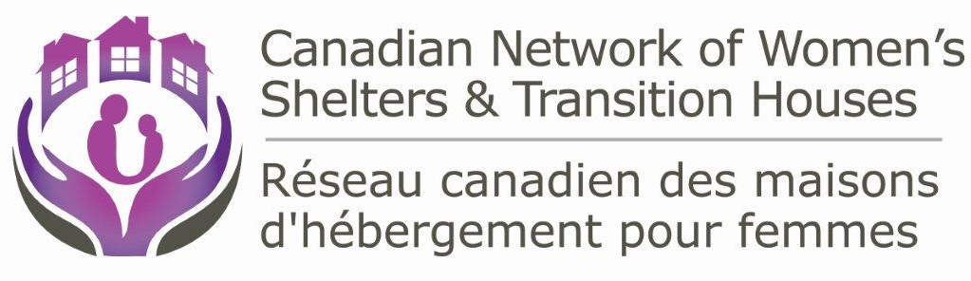
As we begin the 16 days of activism against gender based violence it is important to remind ourselves that Violence against Women is a global epidemic and that no country or woman is immune.
Violence against women is a human rights issue – women have the right to live their lives free of violence. At the root of violence against women are gender inequality and the need for men to exercise power and control over women, be it their intimate partners, colleagues or strangers on the sidewalk. Changing attitudes and practises towards women and girls and ensuring substantive equality involves a commitment from us all as individuals and from all levels of government.
Not long ago, on September 23rd we awoke with the news that three women had been murdered in the Ottawa area. Once again we found ourselves saying this is one time too many. On average 65 women are murdered by their current or past intimate partner each year. These numbers have essentially not changed for the last ten years.
In Monday’s territorial election in the North West Territories, a convicted abuser was re-elected. He had been released from jail early so he could run. Although he was sentenced for 45 days for breaking his wife's wrist, he served 8 days. Now he is an MLA. This is simply not acceptable in 2015.
As the national organization representing shelters and transition houses, it is extremely difficult to accept that every day women and children fleeing violence are turned away from shelters for lack of space. Because lack of space is a constant challenge, shelters also have to ask women to leave even though many times, the women are simply not ready. This was the case of Alberta MLA Maria Fitzpatrick who was forced to return to her abuser not once but twice after running out of time at a women’s shelter.
As a society, we owe it to the women and children fleeing violence to ensure that change is imminent. More needs to be done in the short term by ensuring that services are available and accessible and that women and children have a safe place to stay.
In the long term we need to ensure that we not just address the symptoms but that we look to changing the environment so that individuals can live in safety rather than in fear of gender-based violence and harassment.
Given the pervasiveness of violence against women and the urgency to deal with the issue, leadership at the national level is a must if we want to ensure that women in all areas of the country have access to comparable levels of services and protection. We are thrilled to see that the current government is indeed ready, willing and capable of taking this leadership role.
Having recognized the need for a long term strategy that would not be limited to the symptoms but also to the need for systemic change, the Canadian Network of Women’s Shelters has developed, in collaboration with 23 partners, a Blueprint for Canada’s National Action Plan on Violence Against Women. It recognizes that an effective action plan will need to take a comprehensive and intersectional approach which takes into account the complexities of the issue.

The Blueprint provides a roadmap for Canada’s National Action Plan on Violence against Women. It addresses the continuum of violence against women from cyber violence to sexual violence to domestic violence and provides a concrete vision of what a long term plan could and should look like.

Canada’s Plan will need to be developed in consultation with all stakeholders, including frontline workers and survivors and will need to have high-level leadership and accountability from governments’ at all jurisdictional levels. The Blueprint lays out how we need to address prevention, service responses, legal and justice responses and social policy responses. Work and change in all of these areas needs to occur in a coordinated manner within a long term strategy. It is our only hope of having less women fall through the cracks. It is far time that we begin to connect the dots.

The Network and its partners look forward to working with Minister Hajdu to make this plan a reality and to make use of the Blueprint as a starting point.

Lise Martin is the Executive Director of the Canadian Network of Women’s Shelters & Transition Houses.
The Network brings together 13 provincial and territorial shelter organizations. It works as a unified voice to collaborate, educate, and innovate for systemic change that ends violence against women, making Canada a model for safety in the world.

